**A**

**Micro Project Report**

**On**

**“Arch Based Linux”**



**Submitted by**

**MR. Ashutosh Bhausaheb Palhare**

**DEPARTMENT OF COMPUTER ENGINEERING**

**dnyaneshwar polytechnic bhanashiware**

**maharashtra state board of technical education mumbai**

**2020-2021**

**dnyaneshwar polytechnic bhanashiware DEPARTMENT OF COMPUTER ENGINEERING**



CERTIFICATE

This is to certify that **Mr.Ashutosh Bhausaheb Palhare** of fifth semester of diploma in Computer Engineering of Institute Dnyaneshwar Polytechnic Bhanashiware has successfully completed the micro-project in the subject **“Arch Based Linux”** for academic year 2020 – 2021 as prescribed in the curriculum.

**SUBJECT TEACHER HOD PRINCIPAL**

**INDEX**

|  |  |  |  |
| --- | --- | --- | --- |
| SR.NO. | CONTENTS | | Page No |
| 1 | First Page | | I |
| 2 | Certificate | | II |
| 3 | Index | | III |
| 4 | Annexure –IA(Part A) | | 4 |
| 5 | Annexure –II A(Part B) | | 6 |
|  | 1 | Brief Introduction | 6 |
| 2 | Course Outcomes Addressed | 6 |
| 3 | Literature Review | 7 |
| 4 | Actual Methodology Followed | 7 |
| 5 | Actual Resources Used | 7 |
| 6 | Outputs of the Micro–project | 8 |
| 7 | Skill Developed / Learning Outcomes from this Micro–project | 14 |
| 8 | Benefits of this Micro–project | 15 |
| 9 | Conclusion | 15 |

**Annexure – IA**

**PART A**

**Title of Micro-Project**

**“Arch Based Linux”**

**Brief Introduction**

The project on “Arch Based Linux” is basically formed to enable people to understand how the system works through inside out. This provides a learning experience for users to customize the Linux system according to their requirements. One of the important benefits of this system is that users can exercise more control over the system without depending on someone else’s implementation.

Another benefit of this system is to create a compact Linux system. When a regular installation of this system is done, it results in the inclusion of programs which are rendered unnecessary and they tend to waste disk space or even CPU cycles. The custom built system is a secured system and one gets empowered to audit everything from scratch and create a usable foundation level system.



**Course Outcomes Addressed**

1. To Study and test The “Arch Based Linux”
2. To Collecting the Information about various regulation activities related spectrum allocation
3. To study spectrum and its related things and installation rule

**Abstract**

The project LINUX from scratch is reconstructed again by making use of a previously installed Linux distribution. This previous system is like a starting point that provides necessary programs which includes compiler, linker and shell that builds up the system. The system designed here has five modules. They are ‘create a new Linux native partition and file system’, ‘download the packages and patches’, ‘constructing a temporary system’, ‘constructing a Arch Based Linux system’ and a ‘making a Arch Based Linux system bootable’.

In the first step, the petition that hosts the system is prepared and a file system created to mount it. The system is usually mounted on a dedicated partition and if not available, it creates a partition. After blank partition is created then it can be used to set up a file system. After creating the file system it is made accessible by creating a mount point. All these functions are carried out by the modules.

**Actual Resources Required**

|  |  |  |  |  |
| --- | --- | --- | --- | --- |
| Sr.No. | Name of Resource / Material | Specification | Qty | Remark |
| 01 | Computer | 2GB Ram 160GB HDD | 1 | - |
| 02 | References | Internet | 1 | - |
| 03 | Mobile Communication Magzine | Google | 1 | - |

**Action Plan**

|  |  |  |  |  |
| --- | --- | --- | --- | --- |
| Sr.No. | Details of activity | Planned Start Date | Planned Finish Date | Name of Responsible team members |
| 01 | Selection of Topic for Micro-project |  |  |  |
| 02 | Collection of Information about topic and related things |  |  |  |
| 03 | Prepare a report on Micro-project |  |  |  |
| 04 | Analysis and re inspection of Report |  |  |  |

**Literature Review**

We all use computers on a daily basis. Most of you know about Microsoft Windows and Apple’s macOS. However, did you also know about GNU/Linux also referred to as Linux? This world is dominated by Windows with macOS being in second place, and far down the charts, we see Linux.

Microsoft Windows takes up to about 80% of the market and macOS around 16%. This leaves almost no space for Linux. But don’t stop reading just yet. It is used more than you think as these numbers only reflect desktop usage. Did you know that Android runs on Linux? When you are using Facebook, Instagram, or Google, you are also using Linux. It is the most used server operating system by a fair margin.

**What Exactly is an Operating System?**

An operating system is a piece of software that sits in between the hardware that you interact with and the software that you wish to run. When you are typing on a keyboard or looking at your screen, you are touching the hardware. When you start your web browser you are using software, the web browser is executing code on your CPU (Central Processing Unit).

However, it doesn’t do this directly. It talks with your Operating System, which then talks with your hardware. In essence, it translates and manages hardware so that software can use it.

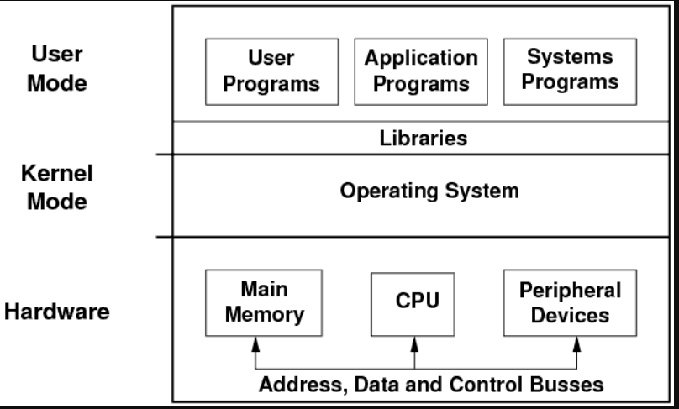

**What is Linux?**

A Misconception about Linux

One common misconception is that Linux is an operating system (OS). This is factually incorrect and it is rather that piece of software that directly communicates with the hardware. An OS is much more than that, it includes software libraries, runtimes, and usually a default set of executables.

Most Linux distributions use GNU as the operating system (including Arch Based Linux). GNU is the child of Richard Stallman and was designed to be Free (As in Freedom) and Open Source. This ranges from a compiler to system libraries as well as commonly used system programs.

In the Linux world, we often say GNU + Linux otherwise referred to as GNU/Linux, because the Operating System is a combination of those 2 projects. Other versions of Linux also exist, for example, the busybox project. These Linux distributions are often more lightweight and can be found in embedded systems.

**Outputs of the Micro–project**

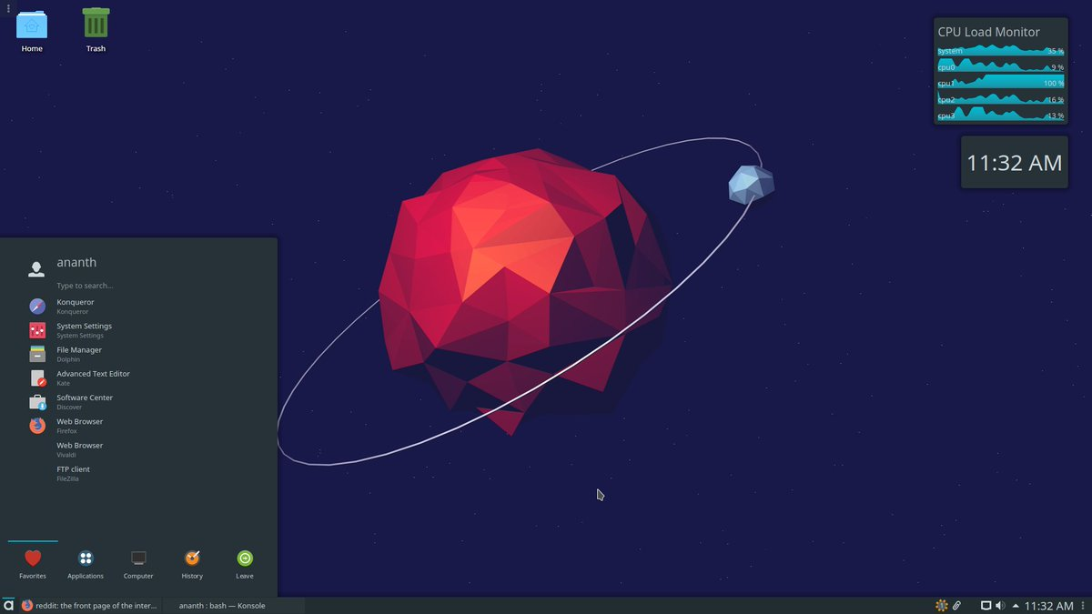

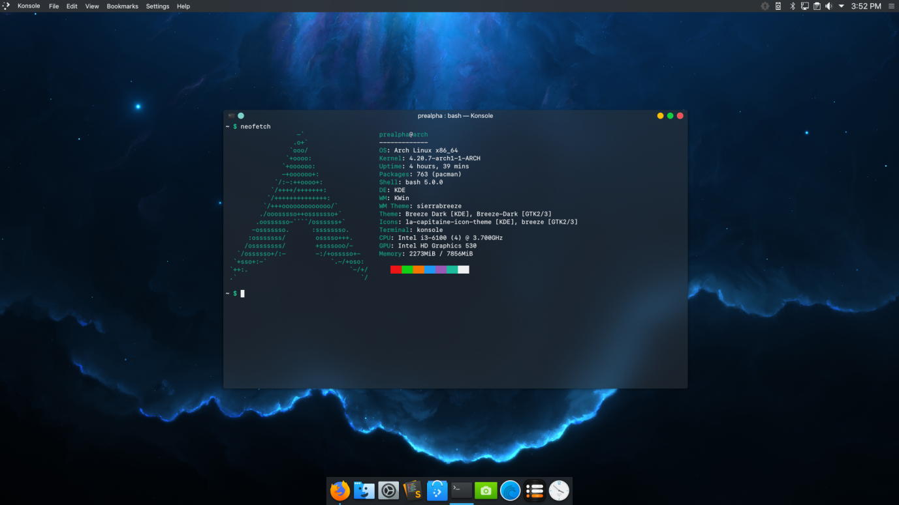

**Skill Developed / Learning Outcomes**

From this project we got so much deep knowledge Arch Based Linux and its working background and also got information about rules and regulation about Arch Based Linux

**Benefits**

**Free Software vs. Open-source Software**

The Linux kernel is known to be open-source software. This means that the source code is openly available. Everybody can read the code and modify it to their heart’s content.

It means we, as a community, can find bugs and fix them or add extra features. This is a very powerful feature and enables collaboration to improve the software, fix bugs, and increase the security.

Open-source software is usually free (not to be confused with free as in freedom). Examples of such software are VLC, MediaWiki (Wikipedia), and Firefox. The open-source development model has led to a vast and interesting ecosystem.

**Advantages**:

•Then we also have free software (free as in freedom), which is even more open than open-source software. It not only allows you to look at the source code and modify it, but it also lets you resell the software for money and make a business out of it. The free software foundation describes it as “the users have the freedom to run, copy, distribute, study, change and improve the software”.

Software like Microsoft Windows is known as proprietary software. This software is not owned by the user, so they are only allowed to use it. The users are not allowed to look at the code, reverse engineer, modify, or redistribute it.

In other words, you have the freedom to do what you want with free and open-source software, but not with proprietary software. This is a key consideration in the Linux world.

**Disadvantages:**

* The Linux is a mostly used in Commandline so its not userfriendly

I think this is a not a disadvantage

Some very useful sofwares are not developed for linux

**Conclusion**

Arch Based Linux GNU/Linux was started as a project so that I had a machine that was totally under my control. It contains a huge number of packages in the repository and provides the needed control for the user. It allows you to completely modify and alter your system. And it comes along with an extensible wiki that covers most (if not all) of your problems.

I would also like to thank the work that Allen McRae and the other developers did on Arch Linux as they founded the basis that later became Arch Based Linux.

Some people might want to take a look at Arch Based Linux and for that reason,